**PRACTICAL: 2**

**AIM:**

The transmission of information needs to be secure over the communication channel and the data has to be confidential. To do so, steganography is the technique of concealing/hiding a secret file, message, audio, or video in another file format. Study and implement the practical approach for Steganography using the following tools: Steghide, StegoSuite & Xiao Steganography.

**THEORY:**

**What is Steganography?**

Steganography is the practice of “hiding in plain sight.” Steganography encodes a secret message within another non-secret object in such a manner as to make the message imperceptible to those who aren’t aware of its presence. Of course, because of this secrecy, steganography generally requires the recipient to be aware that a message is forthcoming.

**How Steganography works**

Steganography works by hiding secret information within a medium, such as an image, audio file, video, or even text, in a way that makes it undetectable to anyone who doesn't know where or how to look. The core idea is to conceal the secret data so that it’s not obvious or suspicious to an observer. One common method is called **Least Significant Bit (LSB)** steganography, where secret data is hidden in the least important bits of a file, like an image or audio file.

For example, in an image, each pixel is made up of three-color values: red, green, and blue. Each of these values is stored as a byte (a group of 8 bits). In LSB steganography, the last bit of each byte is changed to hide secret information. Since this change is so small, it doesn’t noticeably alter the image, making it look almost the same as the original. So, if you want to hide 1 megabyte of data, you would need an image that is 8 megabytes in size.

The same method can also be used for audio and video files, where small changes are made to the sound or visual elements, making it hard for anyone to notice the hidden data.

**Types of steganography**

From a digital perspective, there are five main types of steganography. These are:

1. Text steganography
2. Image steganography
3. Video steganography
4. Audio steganography
5. Network steganography

**Text steganography**

Text steganography involves hiding information inside text files. This includes changing the format of existing text, changing words within a text, using context-free grammars to generate readable texts, or generating random character sequences.

**Image steganography**

This involves hiding information within image files.  In digital steganography, images are often used to conceal information because there are a large number of elements within the digital representation of an image, and there are various ways to hide information inside an image.

**Audio steganography**

Audio steganography involves secret messages being embedded into an audio signal which alters the binary sequence of the corresponding audio file. Hiding secret messages in digital sound is a more difficult process compared to others.

**Video steganography**

This is where data is concealed within digital video formats. Video steganography allows large amounts of data to be hidden within a moving stream of images and sounds. Two types of video steganography are:

* Embedding data in uncompressed raw video and then compressing it later
* Embedding data directly into the compressed data stream

**Network steganography**

Network steganography, sometimes known as protocol steganography, is the technique of embedding information within network control protocols used in data transmission such TCP, UDP, ICMP, etc.

**Uses of steganography**

In recent times, steganography has been mainly used on computers with digital data being the carriers and networks being the high-speed delivery channels. Steganography uses include:

* **Avoiding censorship:** Using it to send news information without it being censored and without fear of the messages being traced back to their sender.
* **Digital watermarking:** Using it to create invisible watermarks that do not distort the image, while being able to track if it has been used without authorization.
* **Securing information:** Used by law enforcement and government agencies to send highly sensitive information to other parties without attracting suspicion.

**How to detect steganography**

The practice of detecting steganography is called ‘steganalysis’. There are various tools that can detect the presence of hidden data, including StegExpose and StegAlyze. Analysts may use other general analysis tools such as hex viewers to detect anomalies in files.

However, finding files that have been modified through steganography is a challenge – not least because knowing where to start looking for hidden data in the millions of images being uploaded on social media every day is virtually impossible.

**CODE:**

|  |
| --- |
| * nano hide.py * python hide.py -e '/home/trushang/Desktop/Dog. bmp' * python hide. py -d ' /home/trushang/Desktop/Dog. bmp' * sudo apt-get install steghide * steghide –version * nano secret.txt * cat secret.txt * steghide --embed -ef ' /home/trushang/Desktop/secret .txt' -cf '/home/trushang/Desktop /steghide_ image.jpeg ' -p 22it116 * steghide --extract -sf '/home/trushang/Desktop/steghide_image . jpeg' -p 22it116 -xf '/home/trushang/Desktop/secrets. txt ' * sudo apt-get install stegosuite * stegosuite gui * copy /b download .jpg + file. zip image .jpg * ren image . jpg image. zip |

**OUTPUT:**

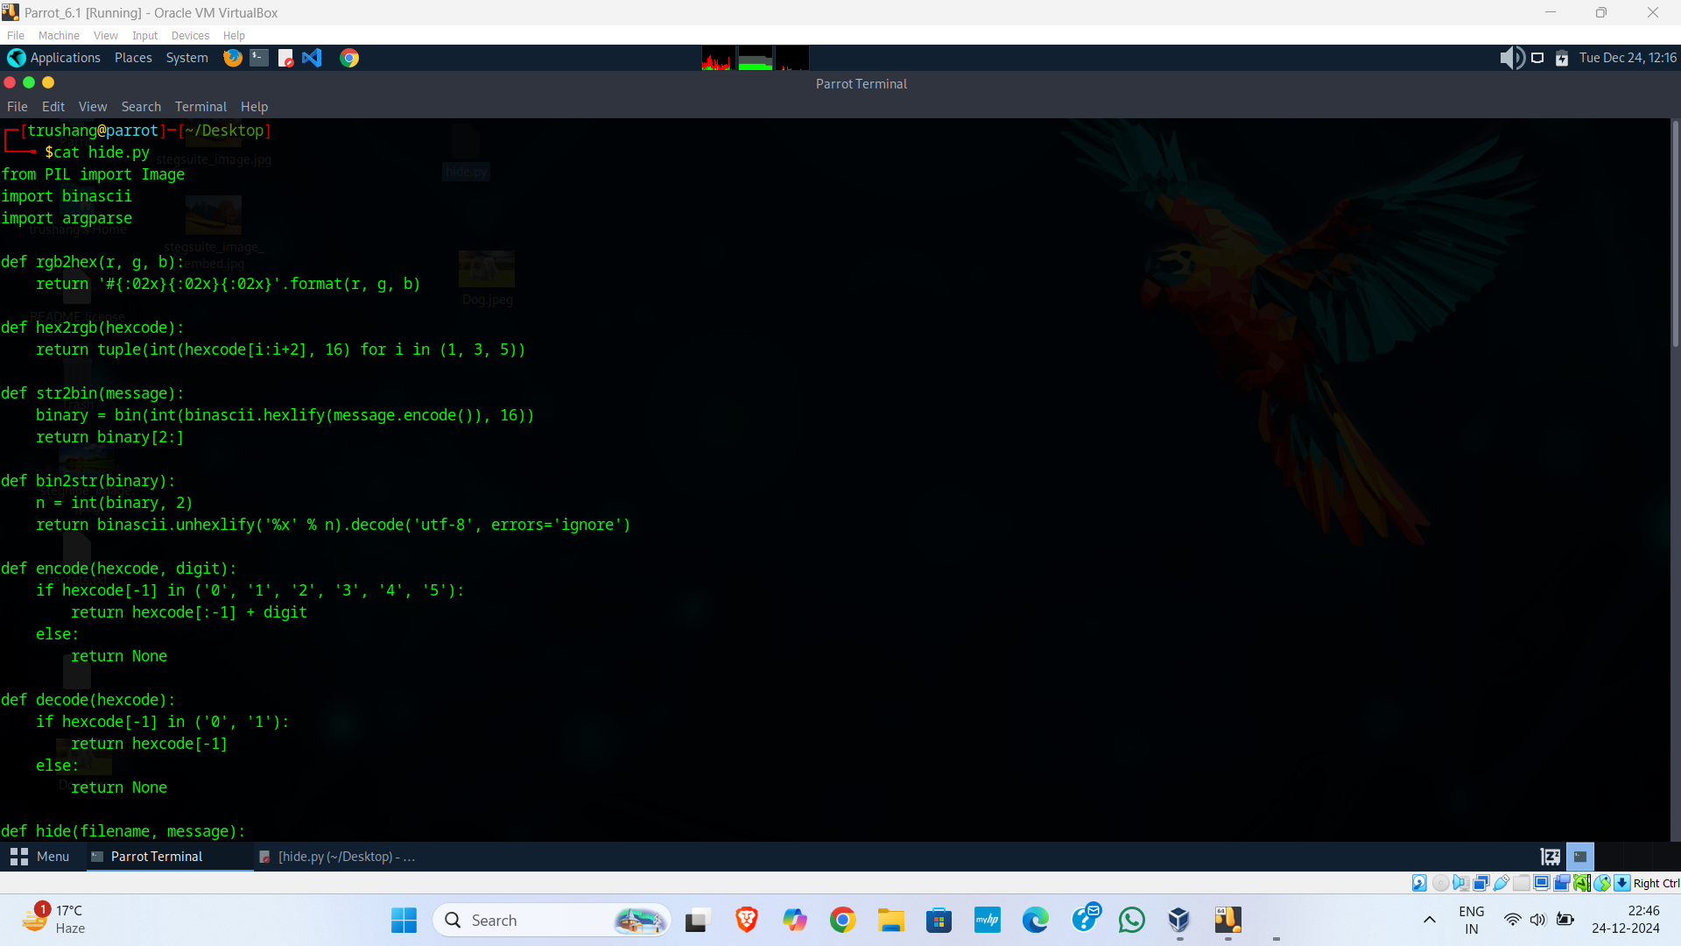

Figure 1:hide.py where we write a logic for hiding data in image

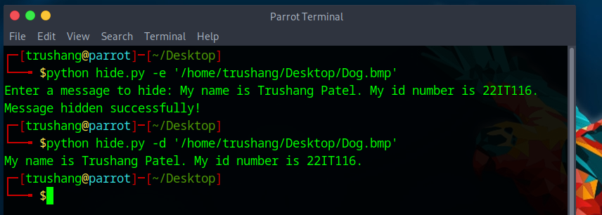

Figure 2:Hide message in image using python code

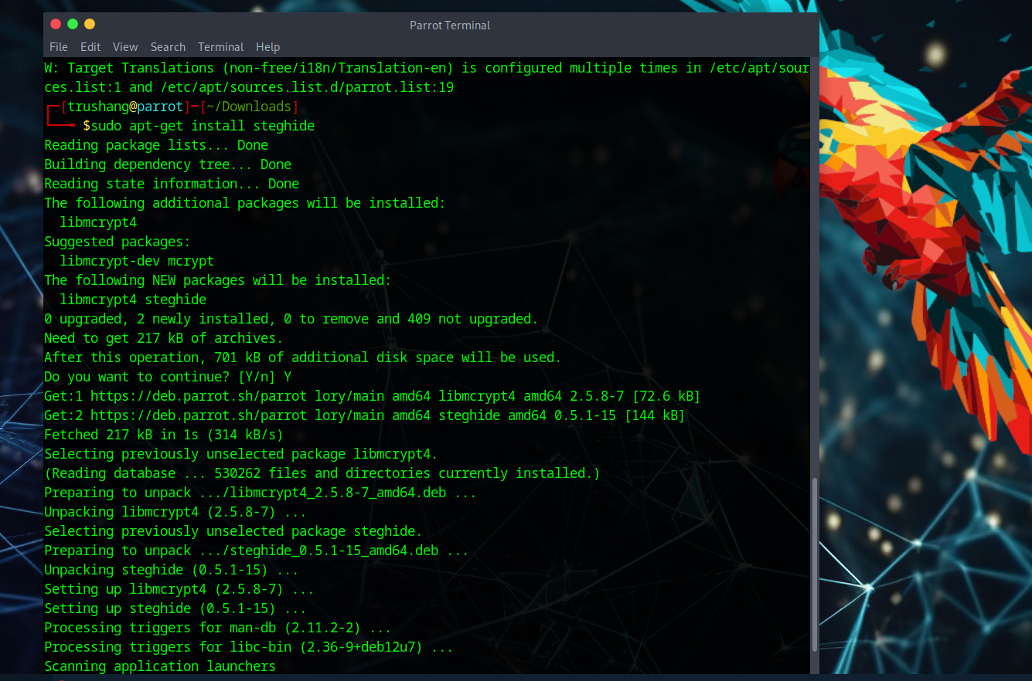

Figure 3:First install steghide in our parrot security os

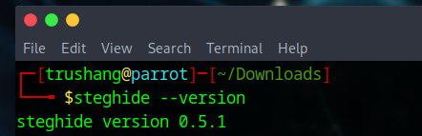

Figure 4:Check the version of steghide

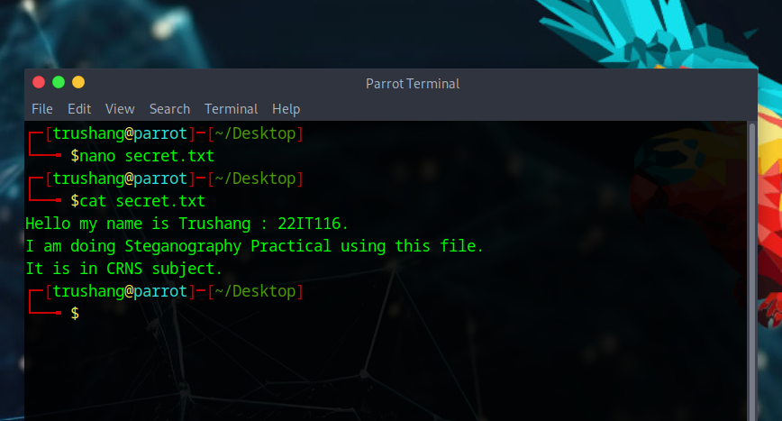

Figure 5: Simple create a secret text file which contains your secret data

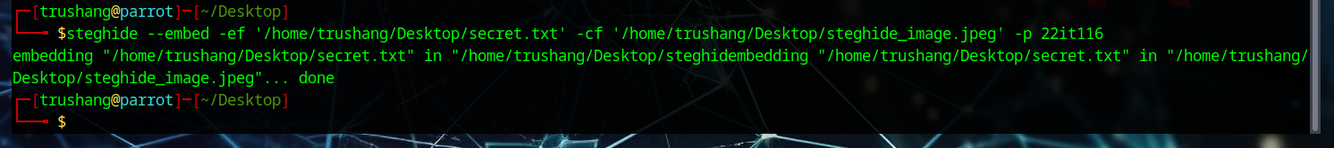

Figure 6: This command hides your secret file into steghide_image file



Figure 7:This command extracts your secret message and store it into secrets.txt



Figure 8:Output of secrets.txt which is hide by sender

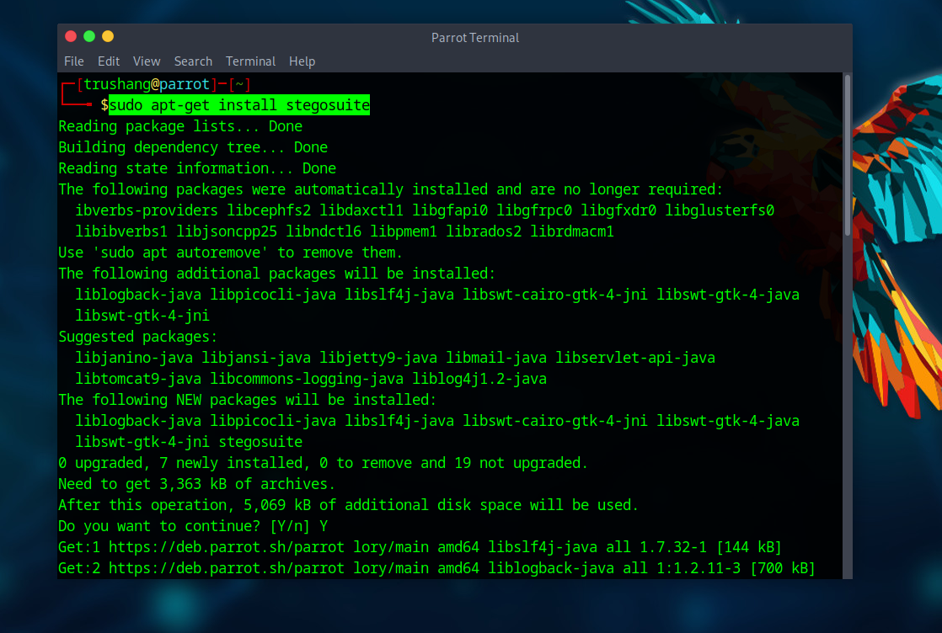

Figure 9:Install Steg suite in your system

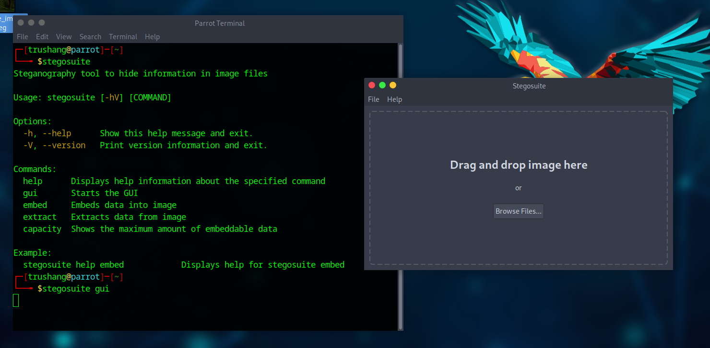

Figure 10:Open stego suite GUI

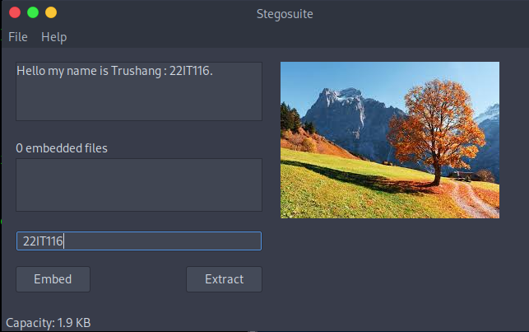

Figure 11:Drag file and set secret message and password

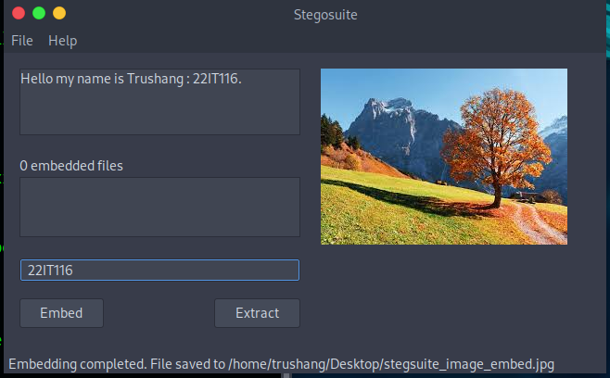

Figure 12:After clicking Embed we create new file with hiding message

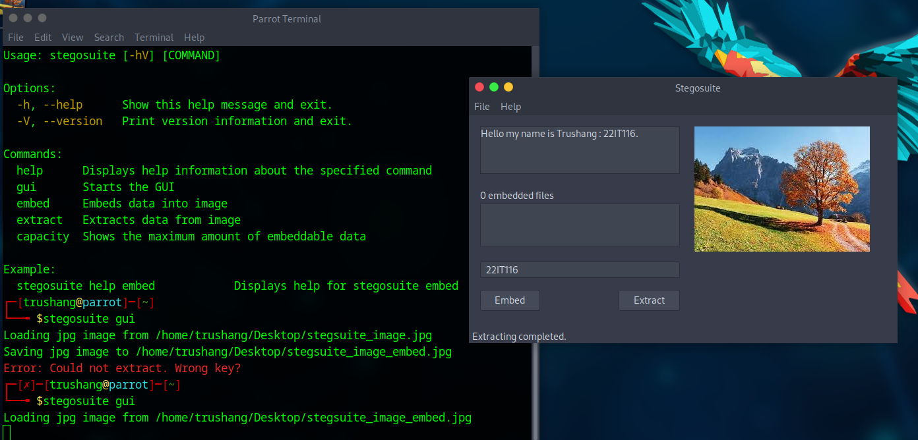

Figure 13: Now Extract the hide data from image

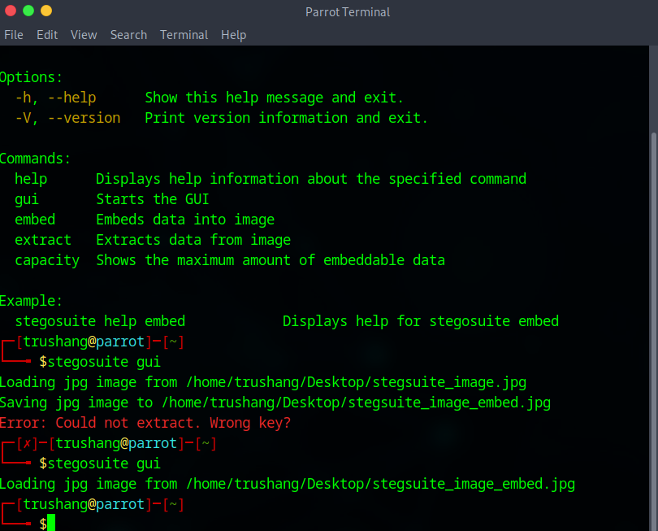

Figure 14:CLI for Steg suite

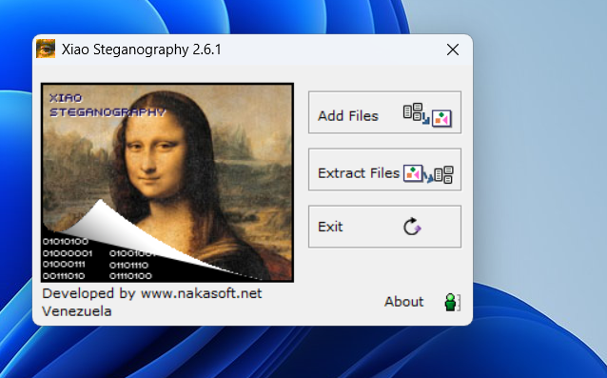

Figure 15:After installing the xiao Steganography

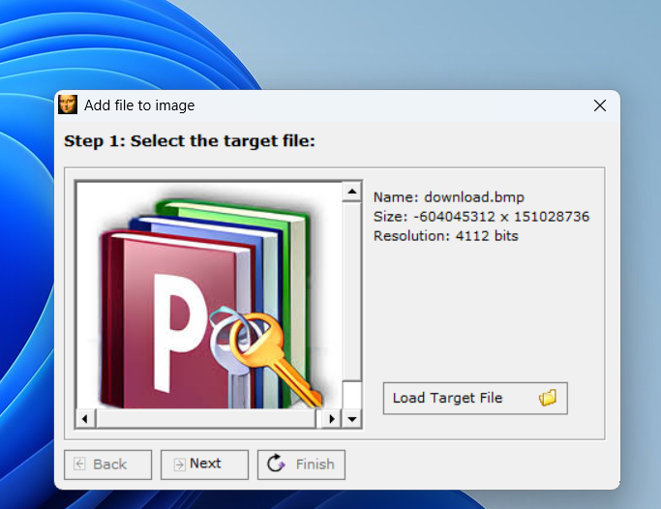

Figure 16:Add image into xios Steganography

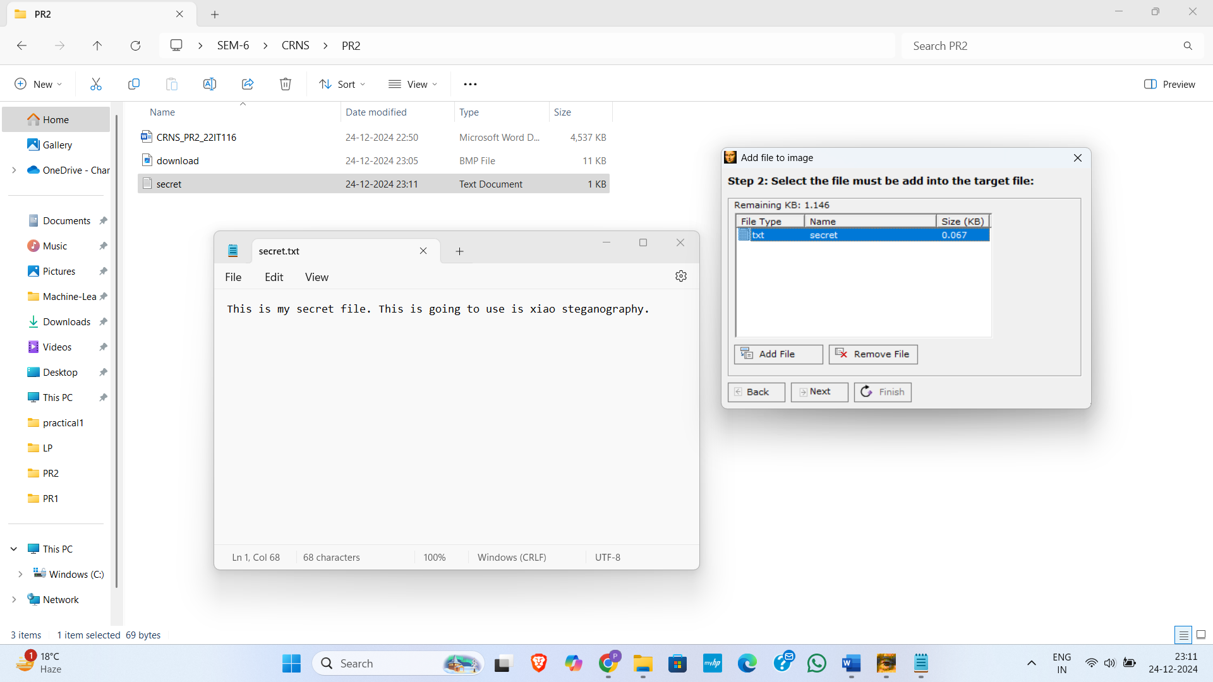

Figure 17: Add secret file to the xiao steganography

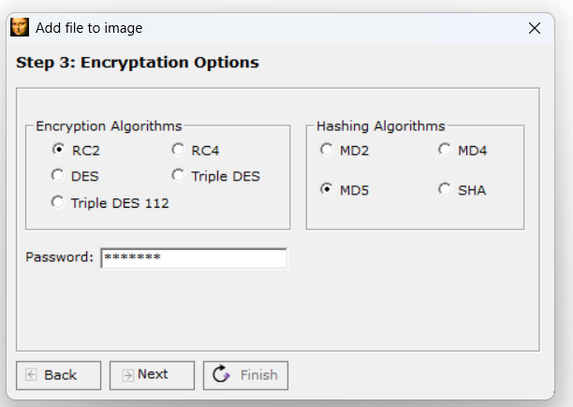

Figure 18:Choose encryption options and set password

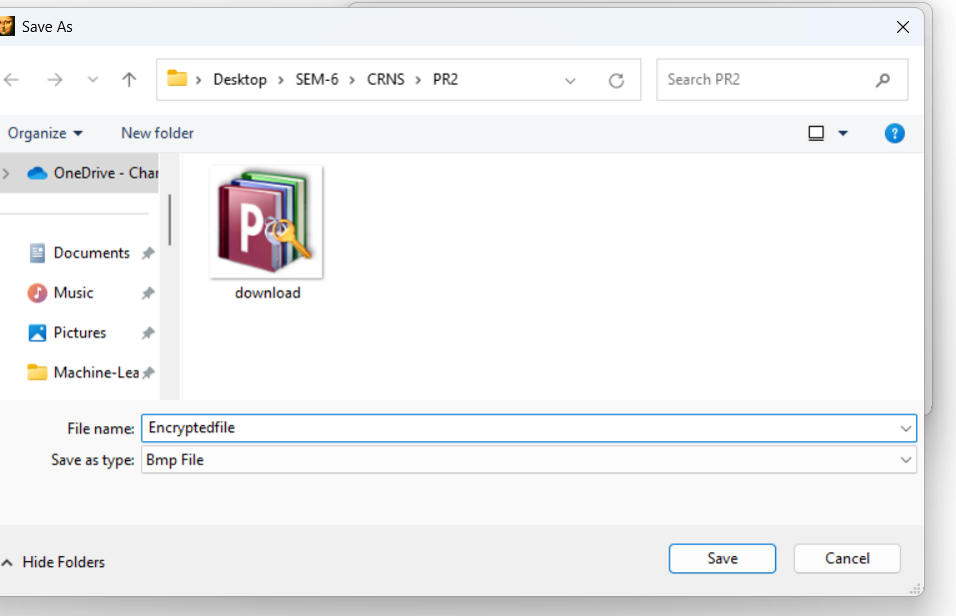

Figure 19:Save file in our local system

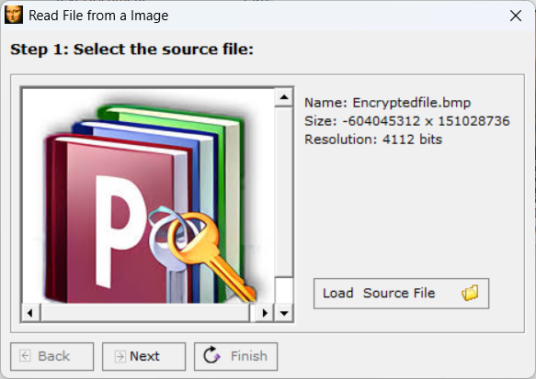

Figure 20: Select stegno file for decryptions

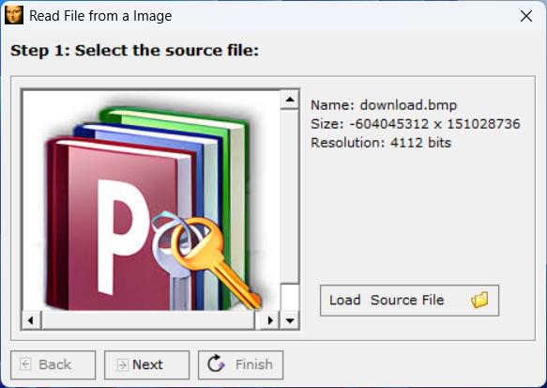

Figure 21:To extraction we use same file as we use for original image

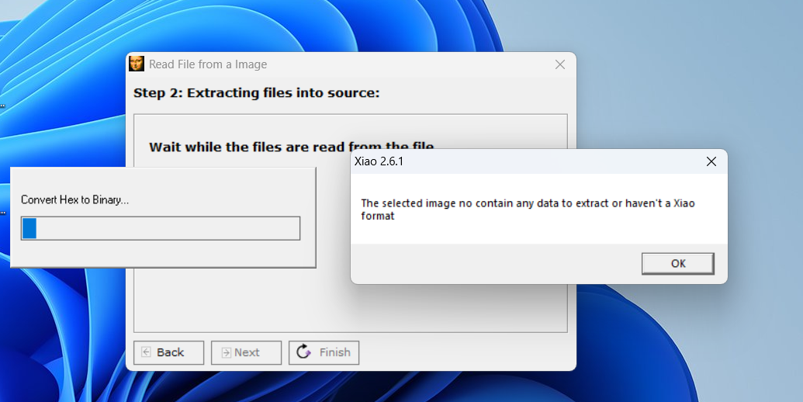

Figure 22:We uploaded original file without steganography so we get output like the selected image no contain any data to extract or haven't a Xiao

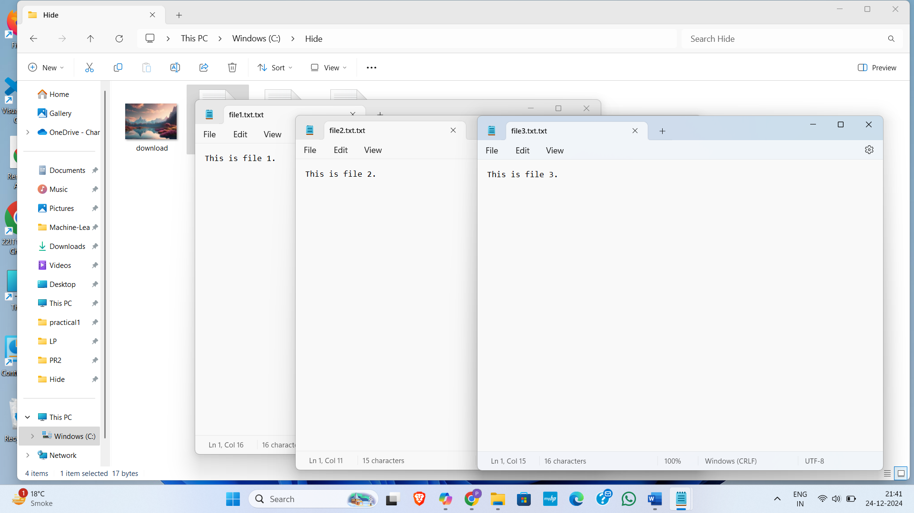

Figure 23: Created a folder in C drive name hide and we have an image name download and three file which we have to hide under image

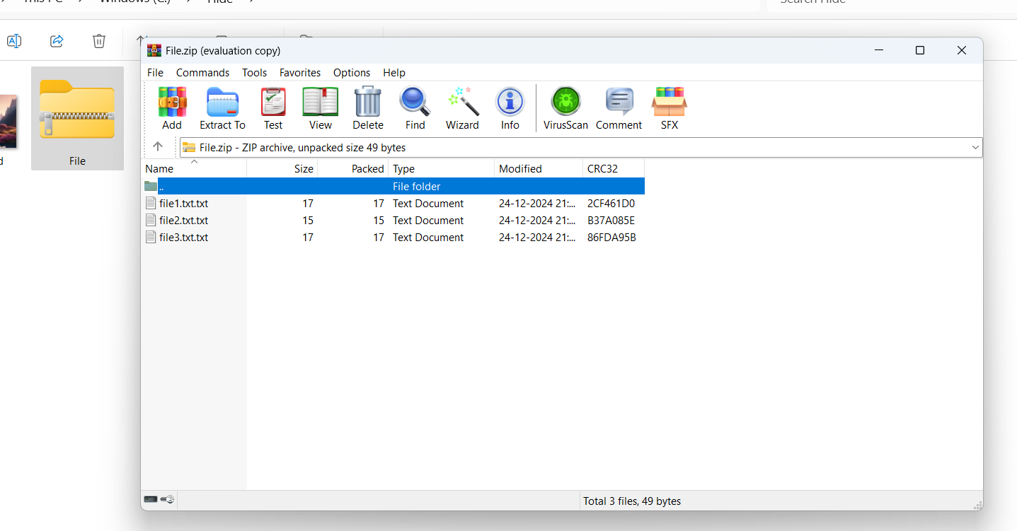

Figure 24: Create ZIP file which you want to hide in image

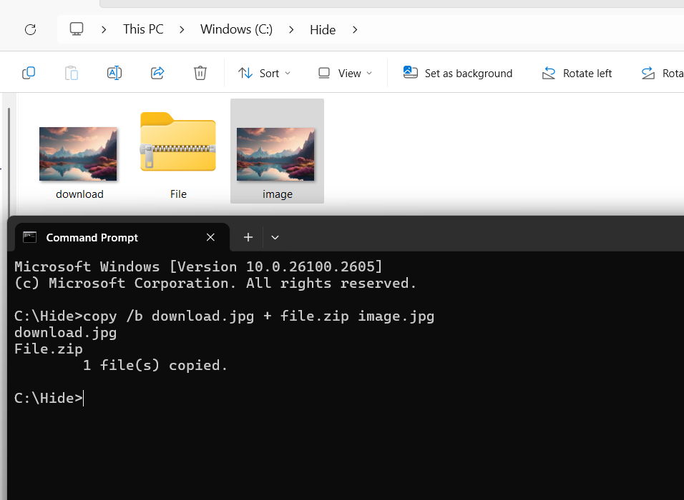

Figure 25:After performing command we create new image with file.zip

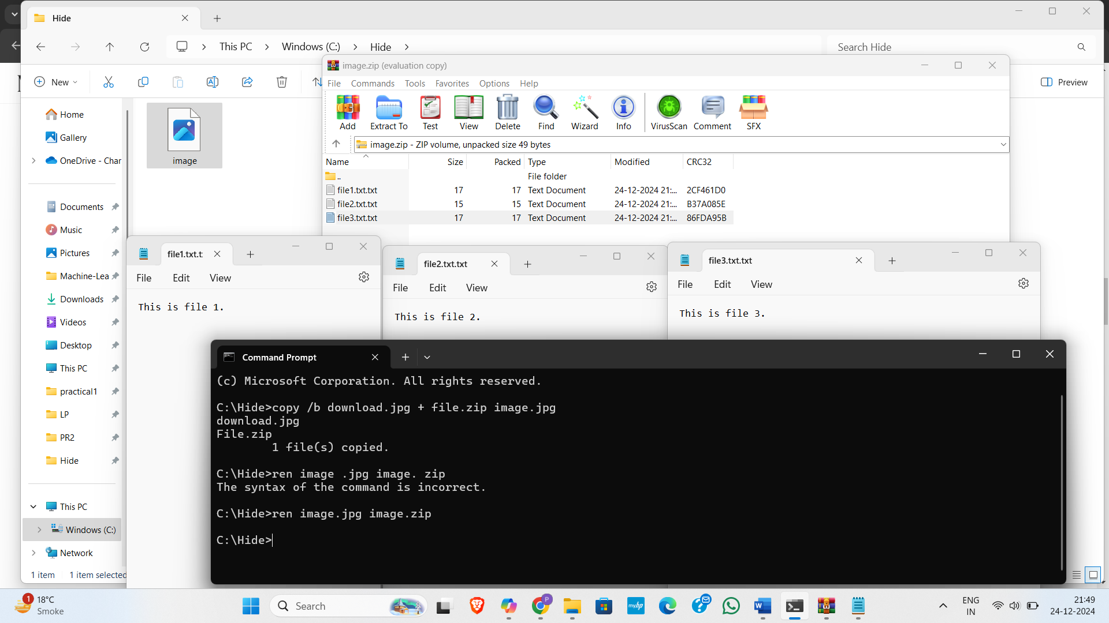

Figure 26:After change image type we can get our zip file with data

**LATEST APPLICATIONS:**

* E-commerce skimming
* SolarWinds
* Industrial enterprises
* Blockchain and Cryptocurrency
* Social Media and Messaging Apps

**LEARNING OUTCOME:** In this practical, we learn about Steganography and tools for steganography like steghide, Steg Suite, Xiao Steganography, using simple CLI and also write python code for steganography.

**REFERENCES:**

1. EC-council : [https://www.eccouncil.org/Steganography](https://www.eccouncil.org/cybersecurity-exchange/ethical-hacking/what-is-steganography-guide-meaning-types-tools/)
2. Kaspersky: [https://www.kaspersky.com/Steganography](https://www.kaspersky.com/resource-center/definitions/what-is-steganography)
3. GeeksforGeeks: [https://www.geeksforgeeks.org/Stegosuite-in-linux/](https://www.geeksforgeeks.org/image-steganography-using-stegosuite-in-linux/)
4. YouTube: <https://www.youtube.com/watch?v=xepNoHgNj0w>